Part Number: PT948-34150-10

PT948-34150-20

Kit Contents
Item # | Quantity Reqd. | Description
1 | 1 | Badge Letter T
2 | 1 | Badge Letter U
3 | 1 | Badge Letter N
4 | 1 | Badge Letter D
5 | 1 | Badge Letter R
6 | 1 | Badge Letter A
Hardware Bag Contents
Item # | Quantity Reqd. | Description
1
2
3
Additional Items Required For Installation
Item # | Quantity Reqd. | Description
1
2
3
Conflicts
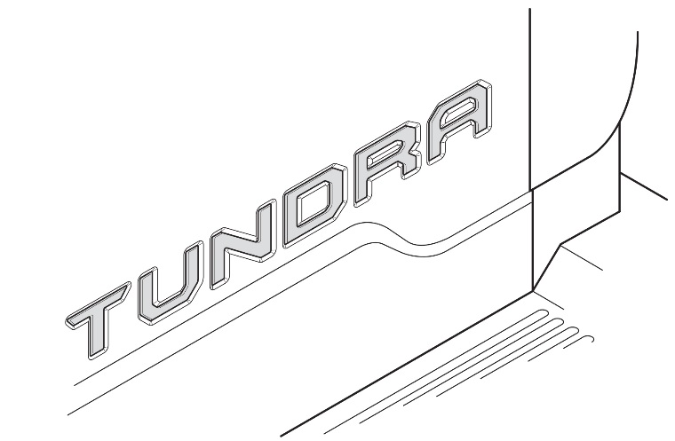
Recommended Tools
Personal & Vehicle Protection | Notes
Safety Glasses / Gloves | Optional
Special Tools | Notes
Non Intrusive IR Temperature Probe / Gun
Soft Felt Block | 0.5” thick with double bevel edges  i.e. Sutherland Felt 32S1 or 3M 71606
Installation Tools | Notes
Heat Source | For temperatures under 70°F
Lint-Free Scratch Resistant Cloth | WypAll L40 Disposable Cloth (Recommended)
Special Chemicals | Notes
Cleaner | VDC Approved Cleaner (PPO)
 | Soap & Water Mixture (DIO)
Clean Water | Bottled Distilled Water
General Applicability
2015- Tundra

Recommended Sequence of Application
Item # | Accessory
1 | Tailgate badge
2
3
*Mandatory
Vehicle Service Parts (may be required for reassembly)
Item # | Quantity Reqd. | Description
1
2
3
Legend
STOP: Damage to the vehicle may occur. Do not proceed until process has been complied with.
OPERATOR SAFETY: Use caution to avoid risk of injury.
CAUTION: A process that must be carefully observed in order to reduce the risk of damage to the accessory/vehicle and to ensure a quality installation.
TOOLS & EQUIPMENT: Used in Figures calls out the specific tools and equipment recommended for this process.
REVISION MARK: This mark highlights a change in installation with respect to previous issue.
SAFETY TORQUE: This mark indicates that torque is related to safety.

Care must be taken when installing this accessory to ensure damage does not occur to the vehicle. The installation of this accessory should follow approved guidelines to ensure a quality installation.

These guidelines can be found in the "Accessory Installation Practices" document.

This document covers such items as:-
- Vehicle Protection (use of covers and blankets, cleaning chemicals, etc.).
- Safety (eye protection, rechecking torque procedure, etc.).
- Vehicle Disassembly/Reassembly (panel removal, part storage, etc.).
- Electrical Component Disassembly/Reassembly (battery disconnection, connector removal, etc.).

Please see your Toyota dealer for a copy of this document.

Prepare for the Installation.
  - Thoroughly clean all installation surfaces. After cleaning with VDC approved cleaner (PPO), follow with a clean water solution.
    - Always use a clean WypAll lint-free scratch resistant cloth.
    - Shake VDC cleaner (PPO) or soap & water mixture (DIO) well.
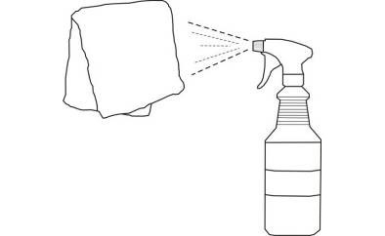
  - Apply VDC cleaner or soap & water mix directly to the cloth. Do not spray cleaning solutions directly to the vehicle (Fig.1-1).
Fig. 1-1

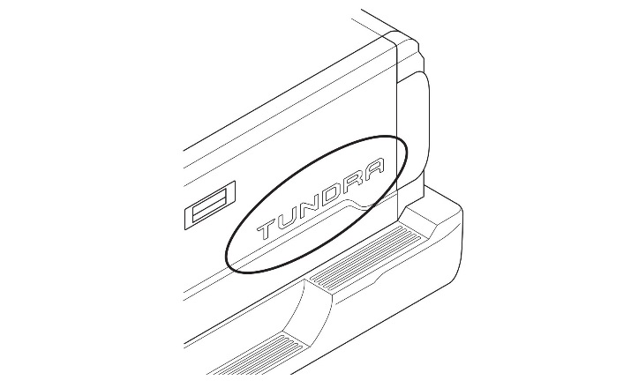
  - Clean the surface thoroughly and wipe dry immediately with a new clean cloth. Do not allow cleaner to air dry (Fig. 1-2).
Fig. 1-2
  - Apply water to a clean cloth. Clean the surface thoroughly to ensure any VDC cleaner or soap & water mixture is completely removed. Wipe dry with a new clean cloth.

  - The tailgate badge and vehicle installation surface must be between 70°F and 110°F at time of installation. A heat source may be used to reach the minimum temperature if necessary.

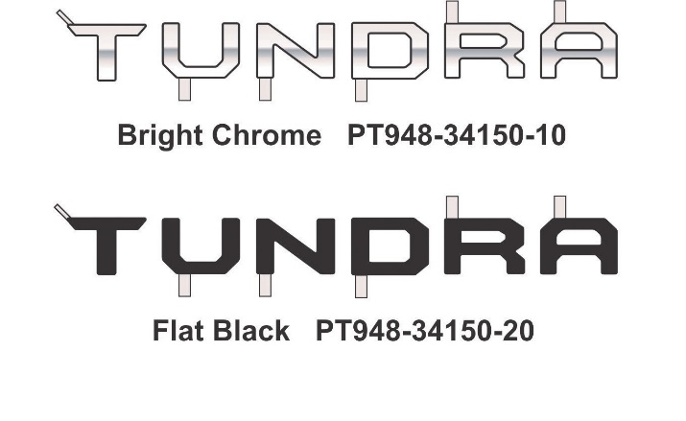
  - Inspect the kit for complete contents and any damage (Fig. 1-3).
Fig. 1-3

Install the Letter T.
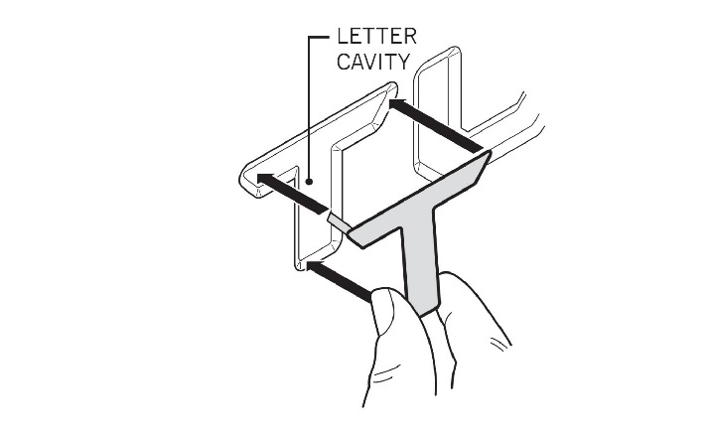
  - Center the letter T inside of the corresponding cavity in the rear tailgate to confirm fit (Fig. 2-1).
Fig. 2-1

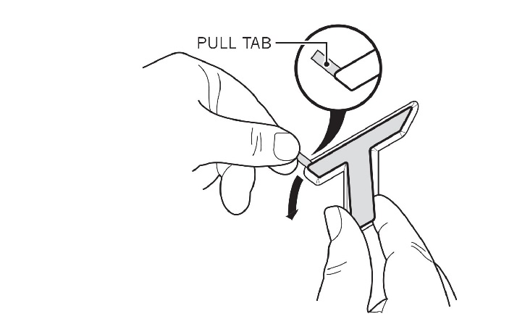
  - Align the top edge of the letter T to the vehicle. Pull downward on the pull tab to remove the adhesive liner from only the upper portion of the letter. Press lightly to adhere (Fig. 2-2).
Fig. 2-2
CAUTION: Do not touch the adhesive during installation.

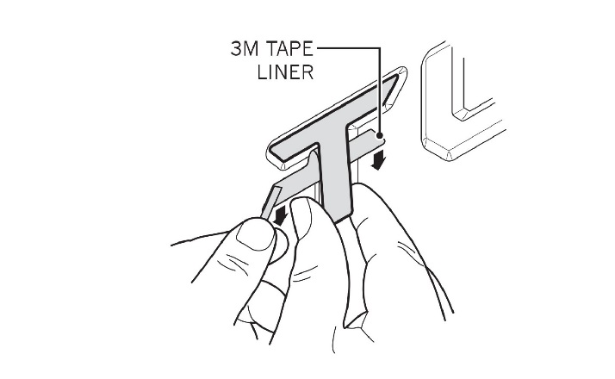
  - Align the middle and bottom of the letter T to the vehicle. Continue pulling the adhesive liner downward, while simultaneously pressing lightly to adhere the letter as you work your way down (Fig. 2-3).
Fig. 2-3
  - Visually verify that the letter T is positioned evenly into the tailgate cavity.

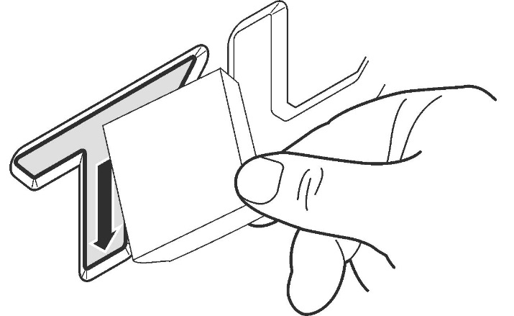
  - Use a soft felt block to press firmly on the letter T from the top edge working downward to the bottom of the letter, to ensure maximum adhesion contact (Fig. 2-4).
Fig. 2-4
Soft felt block

Install the Letter U.
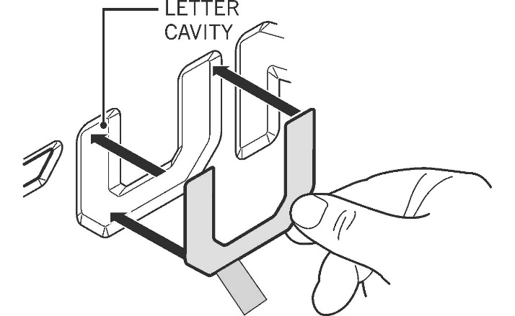
  - Center the letter U inside of the corresponding cavity in the rear tailgate to confirm fit (Fig. 3-1).
Fig. 3-1

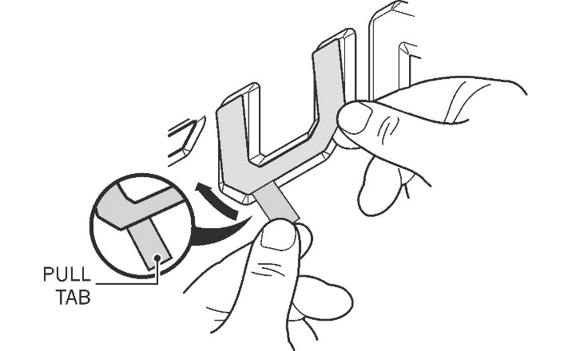
  - Align the bottom edge of the letter U to the vehicle. Pull upward on the pull tab to remove the adhesive liner from only the bottom portion of the letter. Press lightly to adhere (Fig. 3-2).
Fig. 3-2
CAUTION: Do not touch the adhesive during installation.

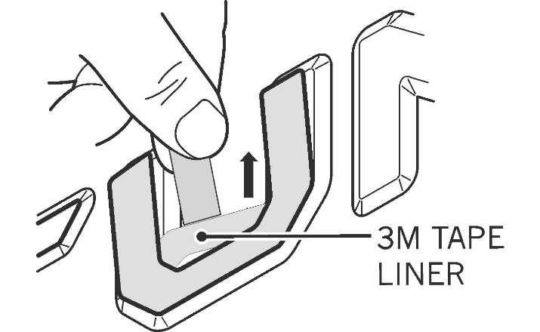
  - Align the left and right side of the letter U to the vehicle. Continue pulling the adhesive liner upward, while simultaneously pressing lightly to adhere the letter as you work your way up (Fig. 3-3).
Fig. 3-3
  - Visually verify that the letter U is positioned evenly into the tailgate cavity.

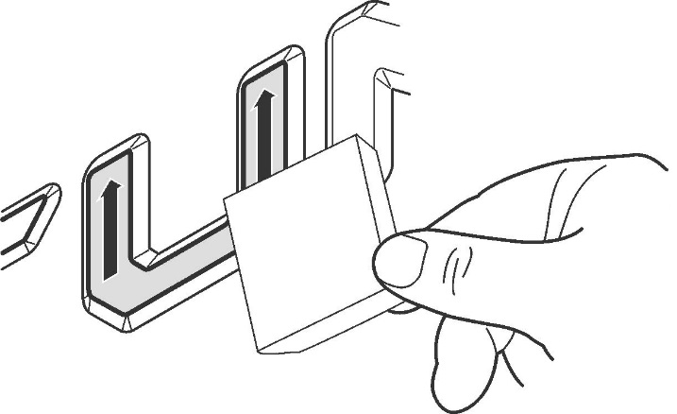
  - Use a soft felt block to press firmly on the letter U from the bottom edge working upward to the top of the letter, to ensure maximum adhesion contact (Fig. 3-4).
Fig. 3-4
Soft felt block

Install the Letter N.
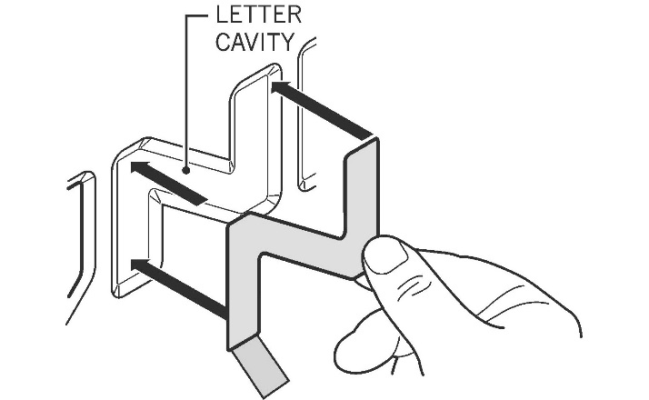
  - Center the letter N inside of the corresponding cavity in the rear tailgate to confirm fit (Fig. 4-1).
Fig. 4-1

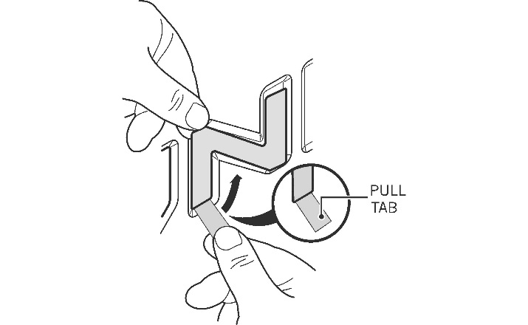
  - Align the left edge of the letter N to the vehicle. Pull upward on the pull tab to remove the adhesive liner from only the left side portion of the letter. Press lightly to adhere (Fig. 4-2).
Fig. 4-2
CAUTION: Do not touch the adhesive during installation.

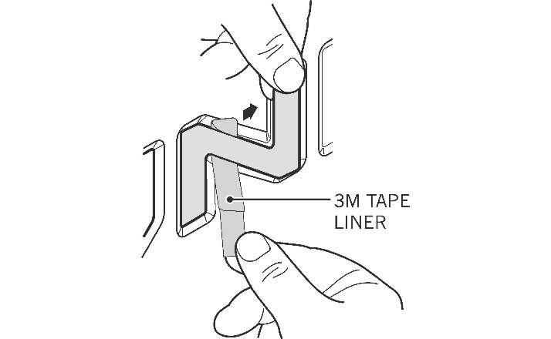
  - Align the middle and right side of the letter N to the vehicle. Continue pulling the adhesive liner towards the right, then upward, while simultaneously pressing lightly to adhere the letter as you work your way right (Fig. 4-3).
Fig. 4-3
  - Visually verify that the letter N is positioned evenly into the tailgate cavity.

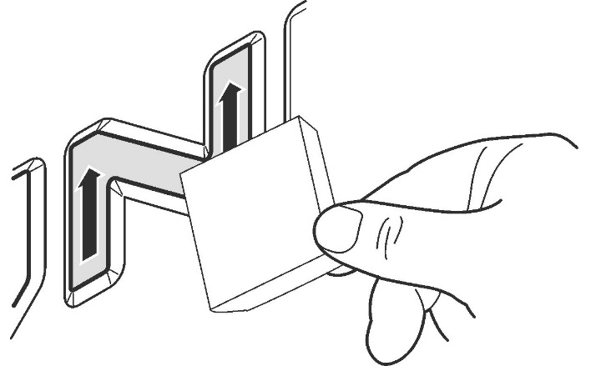
  - Use a soft felt block to press firmly on the letter N from the left side working to the right, through the center of the letter, then upward on the right side of the letter, to ensure maximum adhesion contact (Fig. 4-4).
Fig. 4-4
Soft felt block

Install the Letter D.
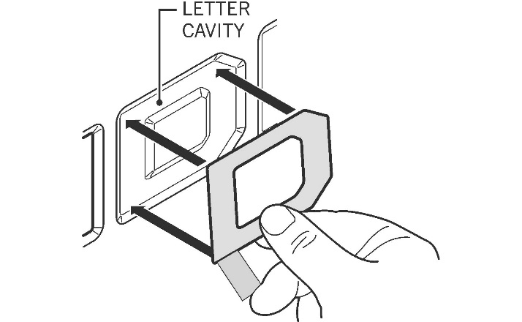
  - Center the letter D inside of the corresponding cavity in the rear tailgate to confirm fit (Fig. 5-1).
Fig. 5-1

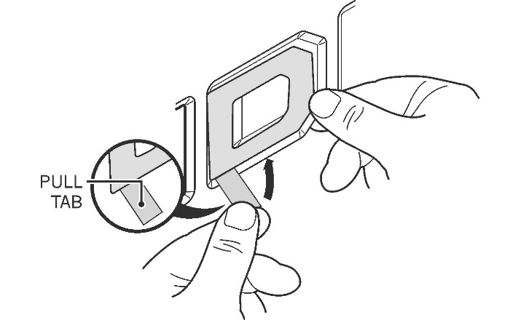
  - Align the bottom edge of the letter D to the vehicle. Pull upward on the pull tab to remove the adhesive liner from only the bottom portion of the letter. Press lightly to adhere (Fig. 5-2).
Fig. 5-2
CAUTION: Do not touch the adhesive during installation.

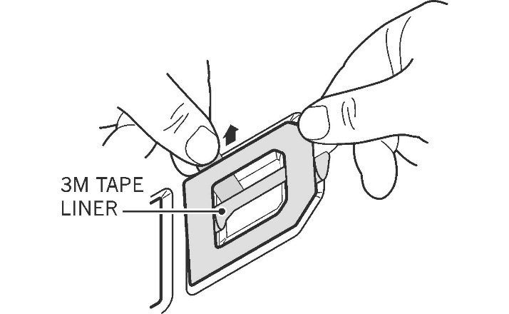
  - Align the middle and top of the letter D to the vehicle. Continue pulling the adhesive liner upward, while simultaneously pressing lightly to adhere the letter as you work your way up (Fig. 5-3).
Fig. 5-3
  - Visually verify that the letter D is positioned evenly into the tailgate cavity.

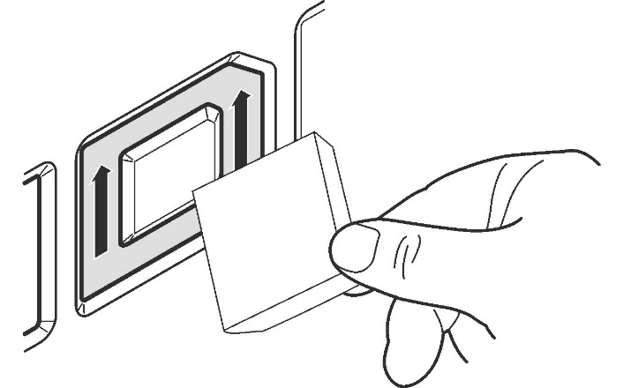
  - Use a soft felt block to press firmly on the letter D from the bottom edge working upward to the top of the letter, to ensure maximum adhesion contact (Fig. 5-4).
Fig. 5-4
Soft felt block

Install Letter the R.
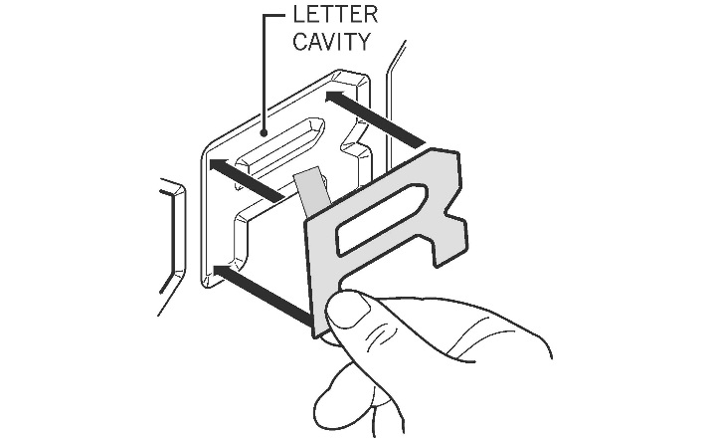
  - Center the letter R inside of the corresponding cavity in the rear tailgate to confirm fit (Fig. 6-1).
Fig. 6-1

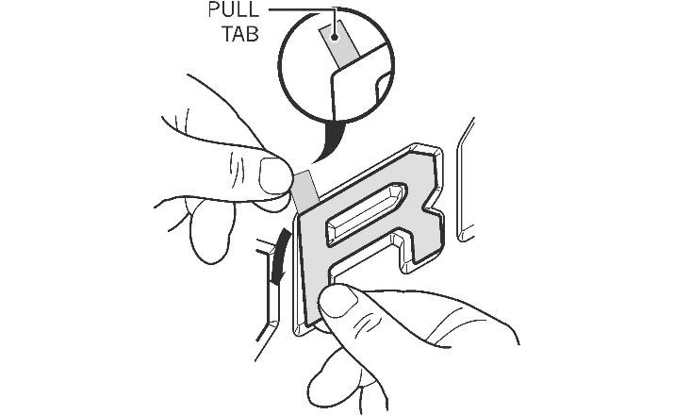
  - Align the top edge of the letter R to the vehicle. Pull downward on the pull tab to remove the adhesive liner from only the upper portion of the letter. Press lightly to adhere (Fig. 6-2).
Fig. 6-2
CAUTION: Do not touch the adhesive during installation.

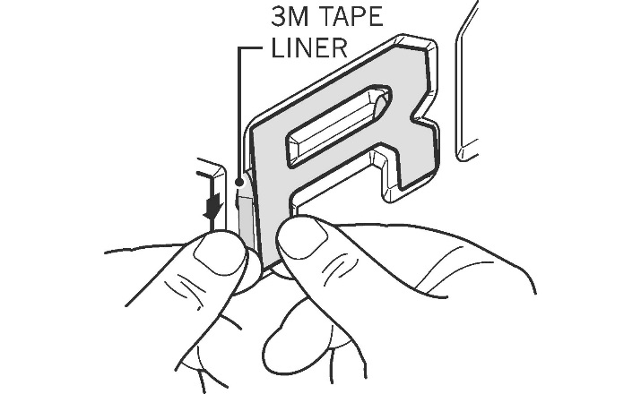
  - Align the middle and bottom of the letter R to the vehicle. Continue pulling the adhesive liner downward, while simultaneously pressing lightly to adhere the letter as you work your way down (Fig. 6-3).
Fig. 6-3
  - Visually verify that the letter R is positioned evenly into the tailgate cavity.

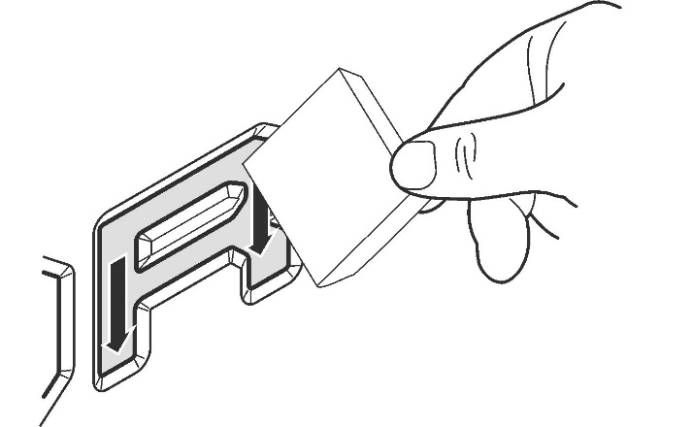
  - Use a soft felt block to press firmly on the letter R from the top edge working downward to the bottom of the letter, to ensure maximum adhesion contact (Fig. 6-4).
Fig. 6-4
Soft felt block

Install the Letter A.
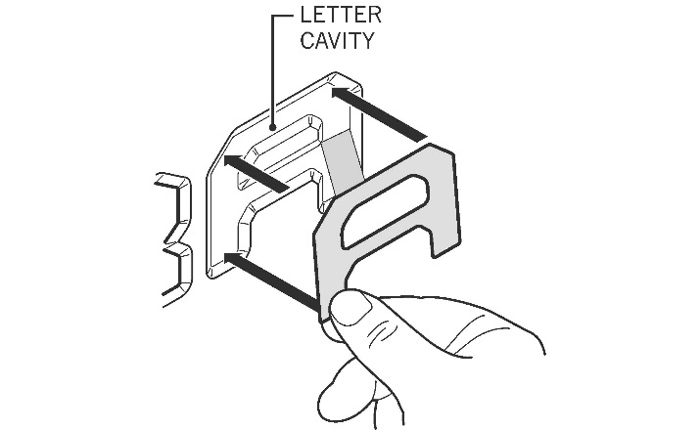
  - Center the letter A inside of the corresponding cavity in the rear tailgate to confirm fit (Fig. 7-1).
Fig. 7-1

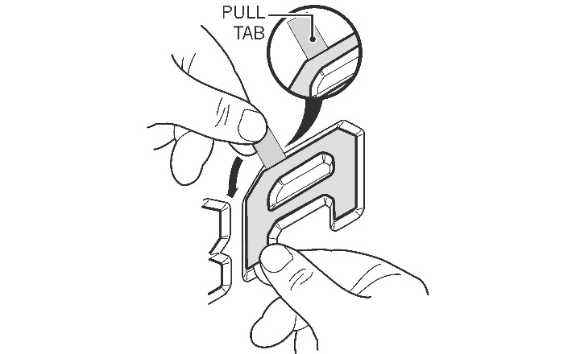
  - Align the top edge of the letter A to the vehicle. Pull downward on the pull tab to remove the adhesive liner from only the upper portion of the letter. Press lightly to adhere (Fig. 7-2).
Fig. 7-2
CAUTION: Do not touch the adhesive during installation.

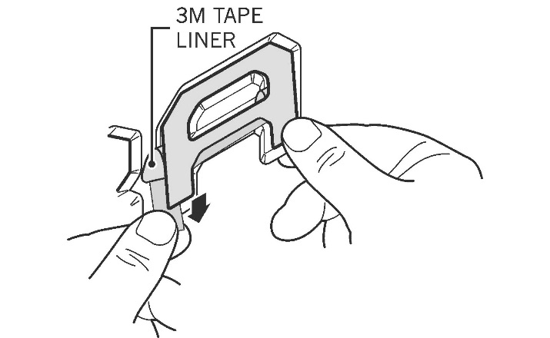
  - Align the middle and bottom of the letter A to the vehicle. Continue pulling the adhesive liner downward, while simultaneously pressing lightly to adhere the letter as you work your way down (Fig. 7-3).
Fig. 7-3
  - Visually verify that the letter A is positioned evenly into the tailgate cavity.

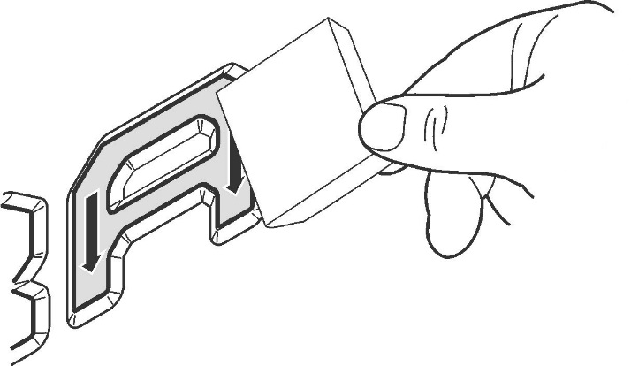
  - Use a soft felt block to press firmly on the letter A from the top edge working downward to the bottom of the letter, to ensure maximum adhesion contact (Fig. 7-4).
Fig. 7-4
Soft felt block

Accessory Function Checks
Tailgate badge adhesive

Tailgate badge alignment

Vehicle Function Checks

Badge letters should be securely attached to the vehicle; no air pockets or lifting.
Badge letters should be aligned evenly inside of the factory tailgate cavity.

Vehicle Appearance Check
After accessory installation, perform a visual inspection.

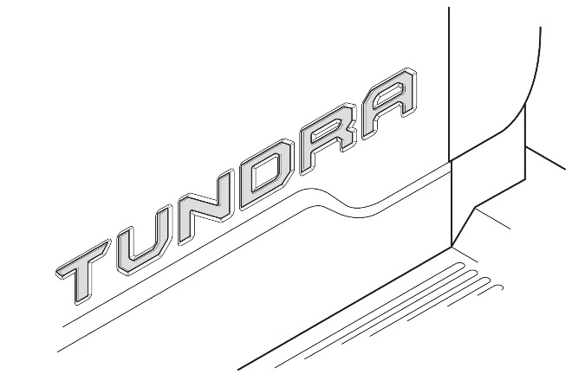
Verify that all six letters are installed.

Ensure no damage (including scuffs and scratches) was caused during the installation process.
(For PPO installations, refer to TMS Accessory Quality Shipping Standard.)

